Google Container Engine
Google Container Engine (GKE) is a cluster management and container orchestration system developed to run and manage Docker containers.
Heapster was a Kubernetes component that monitored and analyzed container clusters. It's now deprecated and has been replaced by the resource metrics API and custom metrics API.
Minikube is a tool that allows you to run a single-node Kubernetes cluster locally on your machine, making it a great option for learning, experimenting, and developing applications on Kubernetes without needing a full-fledged cloud or multi-node setup.
Minikube simplifies the process of setting up a Kubernetes environment on your local machine, allowing you to test and develop applications on Kubernetes without the complexities of a full-scale cluster.
A Kubetcl is a command-line tool or platform through which you can pass commands to a cluster.
Here's a brief overview of what Kubectl can do:
- Create, read, update, and delete Kubernetes resources (pods, services, deployments, etc.)
- Interact with the Kubernetes API server to manage cluster resources
- Monitor the status of resources and diagnose issues
- Manage Kubernetes configurations and secrets
- View logs and metrics for applications running on the cluster

Two main components of Kubernetes architecture are the Master node and the Worker node.
Master node: The master node is the control plane making global decisions inside the cluster. The master node comprises the control plane components responsible for managing and coordinating the cluster. These components are the API server, scheduler, cloud controller manager, and controller manager.
Worker node: The worker node has four very light components, which makes sense because you want to reserve most of the space for your pods. These components are the proxy, the Kubelet, and the container runtime.

The node in Kubernetes that keeps track of resource utilization is the kubelet.

Network Ingress refers to the process of receiving and forwarding incoming data from external sources into a system or network.
In the context of Kubernetes and cloud networking, an Ingress acts as a gatekeeper, managing external access to services within a cluster by routing traffic based on defined rules, offering features like load balancing, SSL termination, and name-based virtual hosting.
Network egress is the process of data leaving a network and moving to an external location.

Types of cloud controller managers:
Node controller: Responsible for managing the lifecycle of nodes in the cluster, such as creating, updating, and deleting nodes
Route controller: Manages ingress and egress traffic for services running in the Kubernetes cluster
Volume controller: Responsible for managing the lifecycle of volumes in the cluster, such as creating, attaching, and detaching volumes.
Service controller: Manages the lifecycle of Kubernetes services, such as creating, updating, and deleting services.

An init container is a type of container in Kubernetes that runs before the main application containers in a pod. The purpose of an init container is to perform initialization tasks or setup procedures that are not present in the application container images. Examples of tasks that an init container might perform include downloading configuration files, setting up a network connection, or initializing a database schema.

CAdvisor stands for container advisor, which discovers active containers and monitors them.
cAdvisor (short for Container Advisor) is an open-source tool integrated into the Kubelet that monitors resource usage and performance of containers, collecting metrics like CPU, memory, filesystem, and network usage, which can then be used for monitoring and analysis.
In Kubernetes, both replica sets and replication controllers ensure that a specified number of pod replicas are running. Replica sets are more advanced and flexible than replication controllers.
 | Replica set | Replication controller
Selector | Set-based selectors | Equality-based selectors
Update strategies | Supports rollbacks and more advanced strategies | More basic strategies
Scalability | More scalable and can handle more replicas | Less scalable
Performance | More performant | Less performant
How can you use Kubernetes for workload distribution optimization?
As Kubernetes helps efficiently optimize resources, it helps with resource distribution. The orchestration tool also ensures that specific resources are used with the application to enhance overall operational efficiency.
Load balancing: Kubernetes provides a built-in load balancer to distribute incoming network traffic to the pods running on the cluster. This helps to evenly distribute the workload across the nodes in the cluster, which can help to optimize resource utilization.
Auto scaling: Kubernetes can automatically scale the number of replicas of a pod based on the resource utilization of the existing pods. This helps to ensure that there are always enough resources available to handle the workload and can help to optimize resource utilization.
Resource management: Kubernetes allows you to specify the resource requirements and limits for each pod, which helps to ensure that the right amount of resources is allocated to each pod.
In Kubernetes, a cluster is a group of machines (nodes) that run containerized applications, managed by a control plane, which orchestrates the deployment and management of these containers across the cluster.
- Key Components of a Kubernetes Cluster:
  - Control Plane: Manages the cluster's state and orchestrates deployments.
  - Worker Nodes: Host the containerized applications (pods).
  - Pods: The smallest unit of deployment in Kubernetes, consisting of one or more containers.
  - Nodes: Physical or virtual machines that host pods.
- How Kubernetes Manages Containers:
  - The Kubernetes API server receives requests to deploy and manage containers.
  - The scheduler determines where to place containers (pods) on the cluster's nodes.
  - The kubelet, running on each node, ensures that containers are running as expected.
  - The kube-proxy handles network traffic routing to the containers.
- Why Use Kubernetes?
  - Orchestration: Kubernetes automates the deployment, scaling, and management of containerized applications.
  - Scalability: Easily scale applications up or down based on demand.
  - Reliability: Kubernetes provides features for self-healing and fault tolerance.
  - Portability: Kubernetes can run on various infrastructure platforms (cloud, on-premise, etc.).
What are Labels and Selectors?
Labels are simple key/value pairs that are attached to Kubernetes objects like pods, deployments, services etc. Labels allow identifying, organizing and connecting resources.
A selector allows selecting resources based on labels. They are commonly used by services, deployments, ingress rules etc to select pods to load balance traffic to.
Why Use Labels and Selectors?
Labels enable grouping objects in flexible ways without tightly coupling them. Some key uses cases include:
- Selecting groups of objects across namespaces and types: Services can select pods from multiple deployments by label instead of being tied to specific deployments.
- Organizing objects for visibility or automation: Objects with common labels can be operated on as a group. Eg. monitor all "app=mysql" pods across environments.
- Layered identification: Pods can have labels beyond what a deployment assigns for flexible usage. Eg "tier=frontend".
- Identifying release version: Label pods with a "version" label like "version=1.2.3" to upgrade or rollback groups of objects.
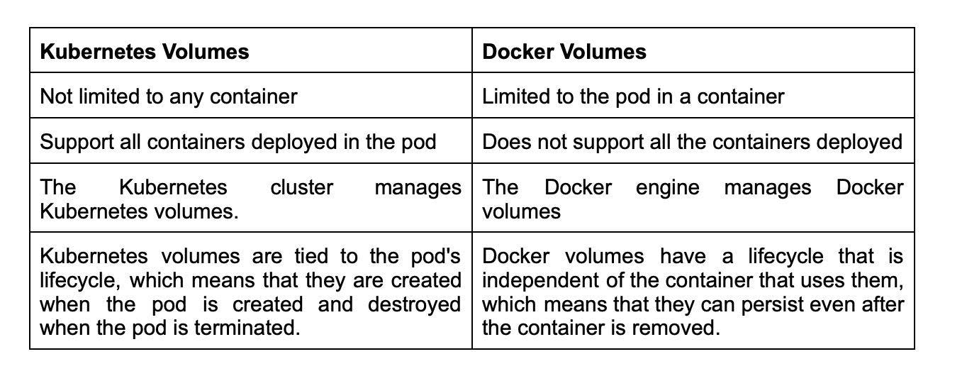
What is PVC?
PVC stands for Persistent Volume Claim, a request made by a user for storage in a Kubernetes cluster. When a user creates a PVC, Kubernetes matches it with an appropriate Persistent Volume (PV) based on the storage requirements and properties specified in the PVC.
Persistent Volumes are network-attached storage devices that multiple pods can access in a cluster. A PVC is a request for a specific amount of storage, which is bound to a single pod or multiple pods, depending on the user's requirements.
Using the default namespace in Kubernetes, while convenient, can lead to resource conflicts, hinder security and resource management, and make troubleshooting more difficult, making it a best practice to create and use custom namespaces for different applications, teams, or environments.

1. Resource Conflicts and Clutter:
- Name Collisions:
The default namespace, by its nature, is a catch-all for resources without a specified namespace, leading to potential name collisions and making it difficult to manage and identify resources.
- Uncontrolled Resource Usage:
Without namespace-specific resource quotas, applications in the default namespace can potentially consume excessive resources, impacting other applications and the cluster's stability.
- Difficult Troubleshooting:
When all resources are in one namespace, it becomes harder to isolate problems and identify the root cause of issues, especially in larger clusters.
2. Security Risks:
- Lack of Isolation:
The default namespace provides minimal isolation, meaning that resources in that namespace are accessible to any user with sufficient privileges, potentially leading to security vulnerabilities.
- Inadequate RBAC:
Applying Role-Based Access Control (RBAC) and Network Policies to the default namespace can be challenging, making it difficult to enforce granular security policies.
- ConfigMap and Secret Exposure:
Secrets and ConfigMaps, which often contain sensitive information, are accessible to anyone with access to the default namespace, posing a significant security risk.
3. Management and Organization:
- Scalability Issues:
Managing a large number of resources within a single namespace can become unwieldy and difficult to scale, especially as the cluster grows.
- Difficulty in Applying Policies:
Enforcing resource quotas, limits, and other policies across the entire cluster becomes challenging when everything is in the default namespace.
- Lack of Isolation:
Pods in different namespaces can still share a node, which can impact resource usage and make it difficult to isolate resource contention issues.
Inside Kubernetes, when the master node fails, the cluster remains operational. There is no effect on the pod creation or any service member changes.
If a worker node fails, the master stops receiving updates, and any pods running on the failed worker node are terminated. The Kubernetes scheduler will then create new replicas of the terminated pods on other healthy worker nodes in the cluster.
In Kubernetes, a headless service allows direct client access to individual pods without a load balancer or a single virtual IP address, exposing the pods' IP addresses via DNS records, useful for stateful applications and service discovery.
Here's a more detailed explanation:
Key Characteristics of a Headless Service:
- No Cluster IP:
Unlike regular Kubernetes services, headless services do not have a cluster IP assigned, meaning they don't act as a proxy or load balancer.
- DNS Record for Each Pod:
Instead, Kubernetes creates DNS records for each pod associated with the headless service, allowing clients to directly connect to those pods.
- Direct Pod Access:
Clients can use the DNS records to find the IP addresses of the pods and establish connections directly, bypassing the need for a service proxy or load balancer.
- Service Discovery:
The DNS records created by the headless service enable service discovery, allowing clients to locate and connect to the pods behind the service.
Use Cases:
- Stateful Applications:
Headless services are particularly useful for deploying stateful applications (e.g., databases, message queues) where each pod needs a unique and stable identity.
- Direct Pod Communication:
When applications need to communicate directly with specific pods, headless services provide a mechanism for that.
- Load Balancing Across Pods:
While not a traditional load balancer, headless services can be used to distribute traffic across pods by allowing clients to connect to multiple pods directly.
- Service Discovery:
The DNS records can be used for service discovery, allowing applications to find and connect to the pods behind the service.
Example:
Imagine you have a distributed database cluster where each database node is a separate pod. A headless service can be used to expose the IP addresses of each database pod, allowing other applications to connect to specific nodes for data access or management.
In Kubernetes, service discovery enables pods to find and communicate with each other or external services using DNS names or environment variables, crucial for maintaining connectivity in a dynamic environment where pods and services change frequently.
Here's a more detailed explanation:
Why Service Discovery is Important in Kubernetes:
- Dynamic Environments:
Kubernetes is designed for dynamic environments where pods (and therefore services) can be created, scaled, or destroyed at any time. Traditional static IP addresses or hostname configurations become impractical.
- Microservices Architecture:
Kubernetes is often used to deploy microservices, where different components need to communicate with each other. Service discovery ensures these components can find each other dynamically.
- Simplified Communication:
Service discovery allows services to communicate using names (e.g., my-service.my-namespace.svc.cluster.local) rather than hardcoded IP addresses, making application development and management easier.
How Service Discovery Works in Kubernetes:
- DNS-Based:
Kubernetes uses its built-in DNS service to provide service discovery.
- Service Objects:
Kubernetes "Service" objects are used to expose network applications running as one or more pods.
- DNS Records:
When a service is created, Kubernetes automatically creates DNS records for it.
- Pod DNS Configuration:
Kubernetes configures pods' DNS so that running containers can look up services by name rather than IP.
- Load Balancing:
Kubernetes can automatically load balance traffic across the pods that belong to a service, ensuring that traffic is distributed efficiently.
- Environment Variables:
Services can also be discovered using environment variables, which are populated with the IP addresses and ports of the services.
Benefits of Kubernetes Service Discovery:
- Simplified Communication:
Services can communicate using names, not IP addresses, simplifying configuration and management.
- Dynamic Scaling:
Pods can be added or removed without disrupting service discovery, allowing for easy scaling.
- High Availability:
If a pod fails, service discovery ensures that traffic is automatically routed to healthy pods, maintaining service availability.
- Decoupled Services:
Services are decoupled from the underlying infrastructure, making them more resilient and easier to manage.
Low-Level Design (LLD) is a critical phase in software development that bridges the gap between high-level design and actual implementation. While high-level design focuses on architectural blueprints, LLD deals with how each component, class, or function is implemented to fulfill the overall system's requirements.
In simpler terms, LLD involves designing classes, methods, interfaces, and interactions between them, ensuring that the code is efficient, maintainable, and scalable. It’s an essential skill for software engineers, especially when building systems that need to be robust, reusable, and easy to modify over time.

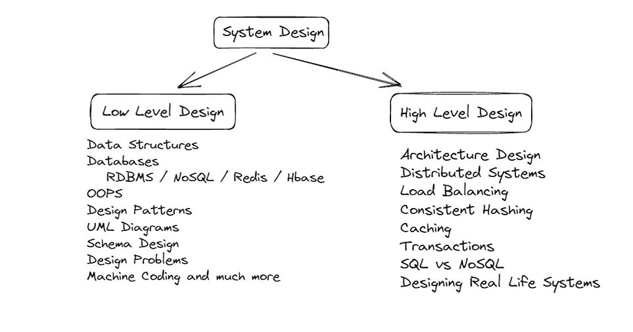Why is Low-Level Design Important?
- Maintainability: A well-thought-out design makes it easier to maintain, extend, and debug code. Poor design leads to technical debt, making future changes costly.
- Scalability: Good LLD ensures that your code is scalable, both in terms of performance and in supporting new features as the system evolves.
- Reusability: Well-designed components can be reused across different parts of a system or in entirely different projects.
- Clarity: With a well-defined design, engineers can understand how various parts of the system fit together, making collaboration easier.
To bridge the gap between LLD concepts and real code, let's break down the process of designing a low-level diagram through the following steps:
Step 1:Object Oriented Principles
Step 2:SOLID Principles
Step 3:Design Patterns
What is High-Level Design?
As discussed above, High-Level Design (HLD) is a phase in the software development life cycle (SDLC) where the overall architecture and structure of a software system or application are planned and documented comprehensively. It is an essential step that bridges the gap between the requirements specification and the actual implementation of the system. The primary goal of High-Level Design is to create a blueprint or roadmap for the software that guides the development team in building a system that meets the desired functionality, performance, and quality criteria. Here's a concise breakdown:
- Requirements Analysis: Understand functional and non-functional requirements by involving stakeholders and end-users.
- System Architecture: Define how software components interact, handle data flow, and achieve functionality.
- Component Design: Detail each major module's structure, behavior, and data processing mechanisms.
- Data Design: Outline data structure, databases, and data flows to ensure efficient storage and retrieval.
- Interface Design: Define communication protocols, APIs, and interactions between software parts.
- Security Design: Address authentication, authorization, encryption, and system security.
- Performance Design: Consider response time, scalability, and resource optimization strategies.
- Error Handling: Plan mechanisms for error reporting, logging, and graceful recovery.
- Technology Selection: Choose appropriate tech, languages, and tools aligned with project needs and expertise.
- Documentation: Create detailed documentation covering design decisions, architecture, data models, interfaces, and more.
The high-level design establishes a foundation for software development, guiding the team toward meeting goals and ensuring a clear path for the coding and testing phases.
High-level Design Decisions Impacting Testing Strategies
- Architecture: Influences integration and end-to-end testing requirements.
- Technology Stack: Determines tools and approaches for compatibility, performance, and security testing.
- Data Flow: Requires validation, transformation, and consistency testing for data movement.
- Scalability: Drives performance and load testing to ensure the system handles varying workloads.
- Security Measures: Shapes scope of security testing, including vulnerability assessments.
Common Pitfalls
- Lack of Clear Requirements:
  - Mistake: Designing without clear requirements.
  - Solution: Gather and validate detailed requirements from stakeholders.
- Over-Engineering:
  - Mistake: Building overly complex solutions.
  - Solution: Follow the KISS principle; design for current needs.
- Underestimating Scalability:
  - Mistake: Ignoring scalability needs.
  - Solution: Plan for scalability; use appropriate architecture.
- Ignoring Security:
  - Mistake: Neglecting security concerns.
  - Solution: Integrate security practices into design.
- Tight Coupling:
  - Mistake: Creating tightly coupled modules.
  - Solution: Aim for loose coupling; use Dependency Injection.
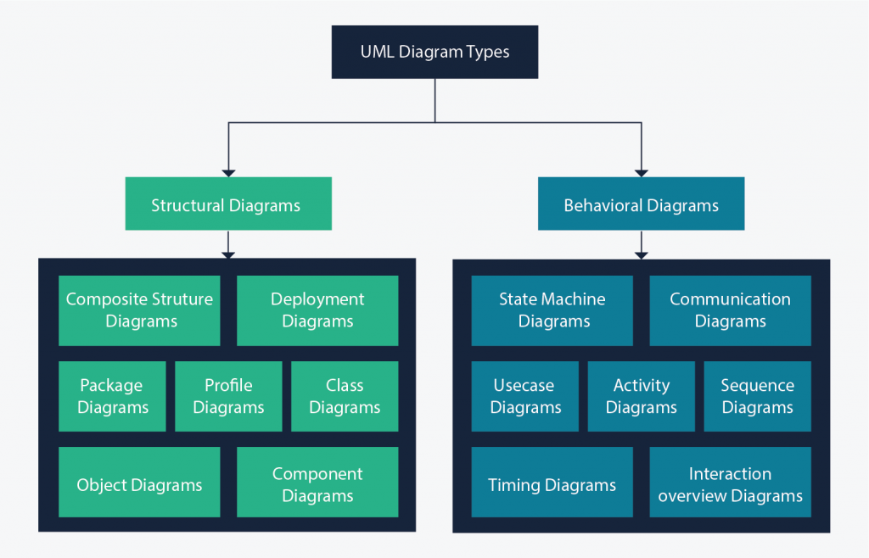

Class Diagram
Class diagrams are the main building block of any object-oriented solution. It shows the classes in a system, attributes, and operations of each class and the relationship between each class.
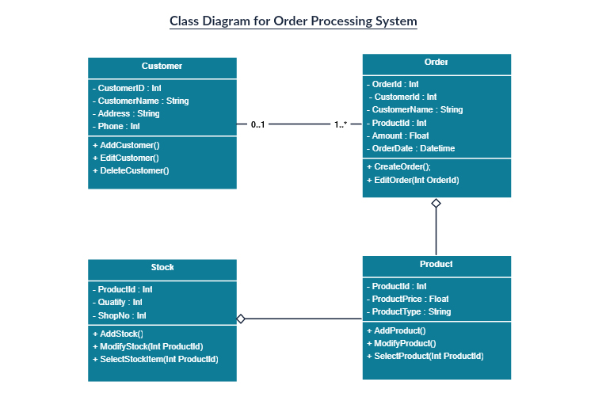

A component diagram displays the structural relationship of components of a software system. These are mostly used when working with complex systems with many components. Components communicate with each other using interfaces. The interfaces are linked using connectors. The image below shows a component diagram.
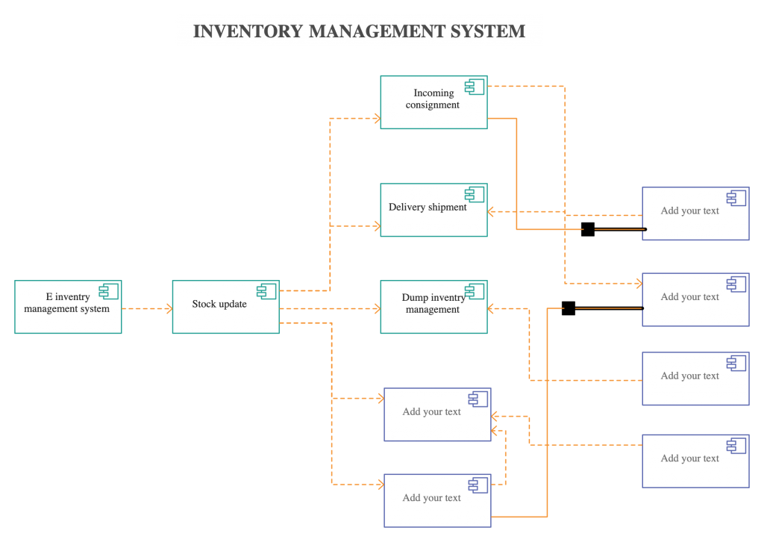
A deployment diagram shows the hardware of your system and the software in that hardware. Deployment diagrams are useful when your software solution is deployed across multiple machines with each having a unique configuration. Below is an example deployment diagram.
Object Diagram
Object Diagrams, sometimes referred to as Instance diagrams are very similar to class diagrams. Like class diagrams, they also show the relationship between objects but they use real-world examples.
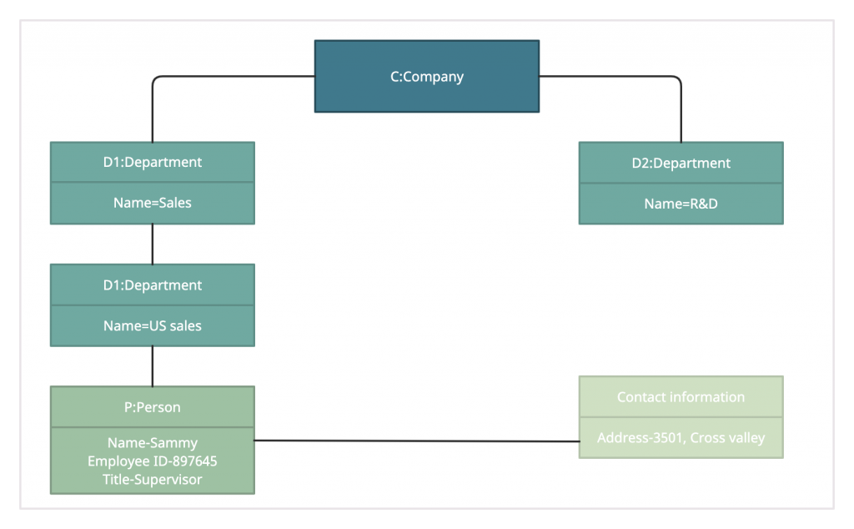
Package Diagram
As the name suggests, a package diagram shows the dependencies between different packages in a system. Check out this wiki article to learn more about the dependencies and elements found in package diagrams.
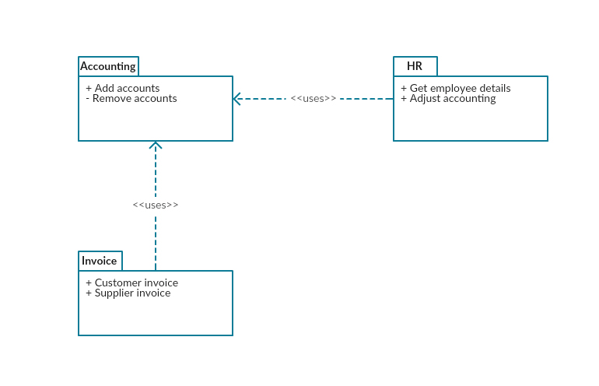
Profile Diagram
Profile diagram is a new diagram type introduced in UML 2. This is a diagram type that is very rarely used in any specification. For more profile diagram templates, visit our diagram community.
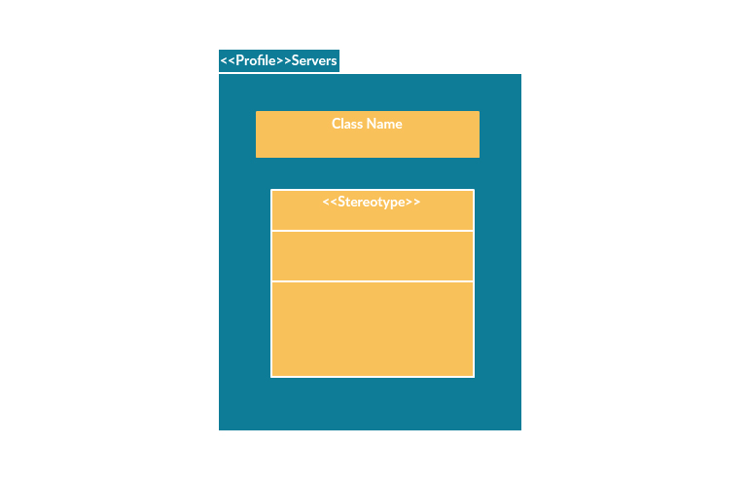

Composite Structure Diagram
Composite structure diagrams are used to show the internal structure of a class. Some of the common composite structure diagrams.
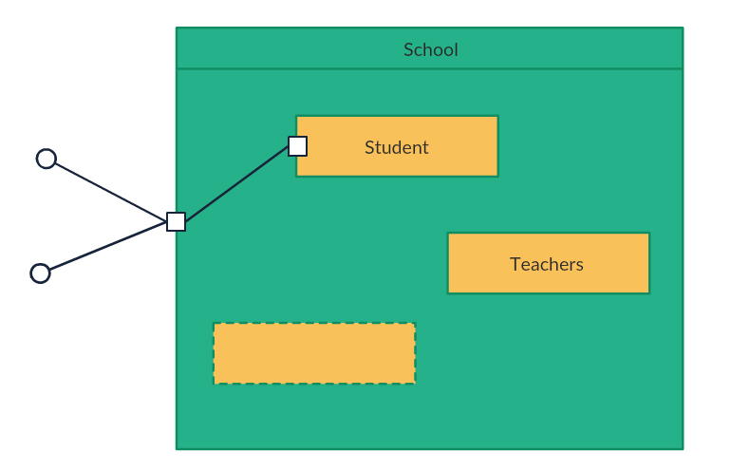
Use Case Diagram
As the most known diagram type of the behavioral UML types, Use case diagrams give a graphic overview of the actors involved in a system, different functions needed by those actors and how these different functions interact.
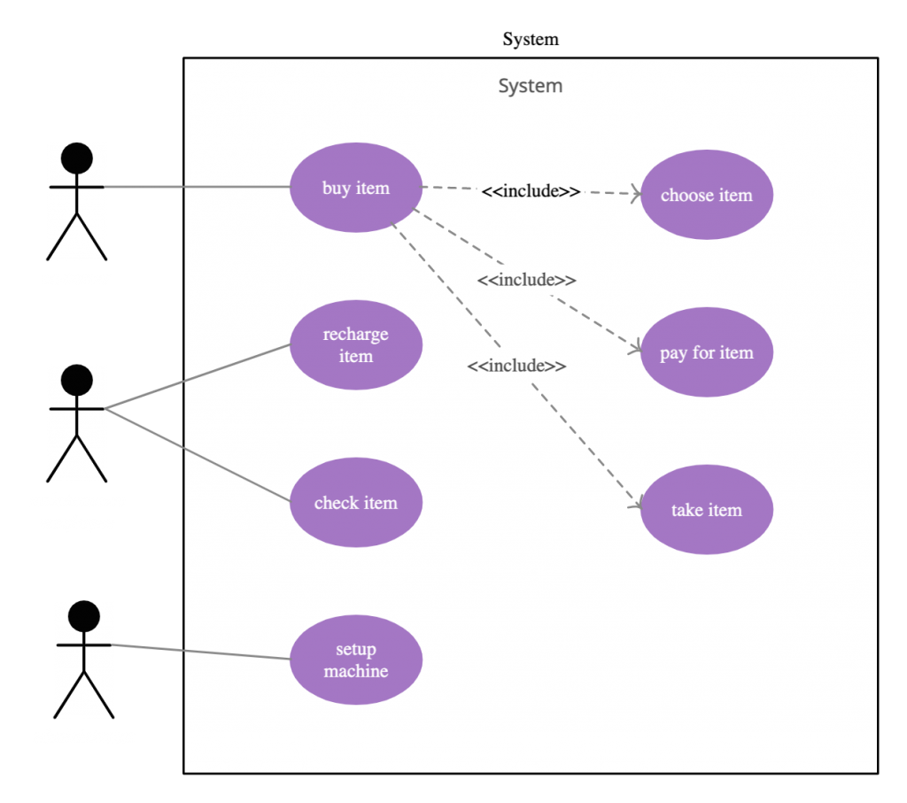

Activity Diagram
Activity diagrams represent workflows in a graphical way. They can be used to describe the business workflow or the operational workflow of any component in a system. Sometimes activity diagram examples are used as an alternative to State machine diagrams. Check out this wiki article to learn about symbols and you can also refer this easy guide to activity diagrams. You can easily draw activity diagram using online activity diagram tool.
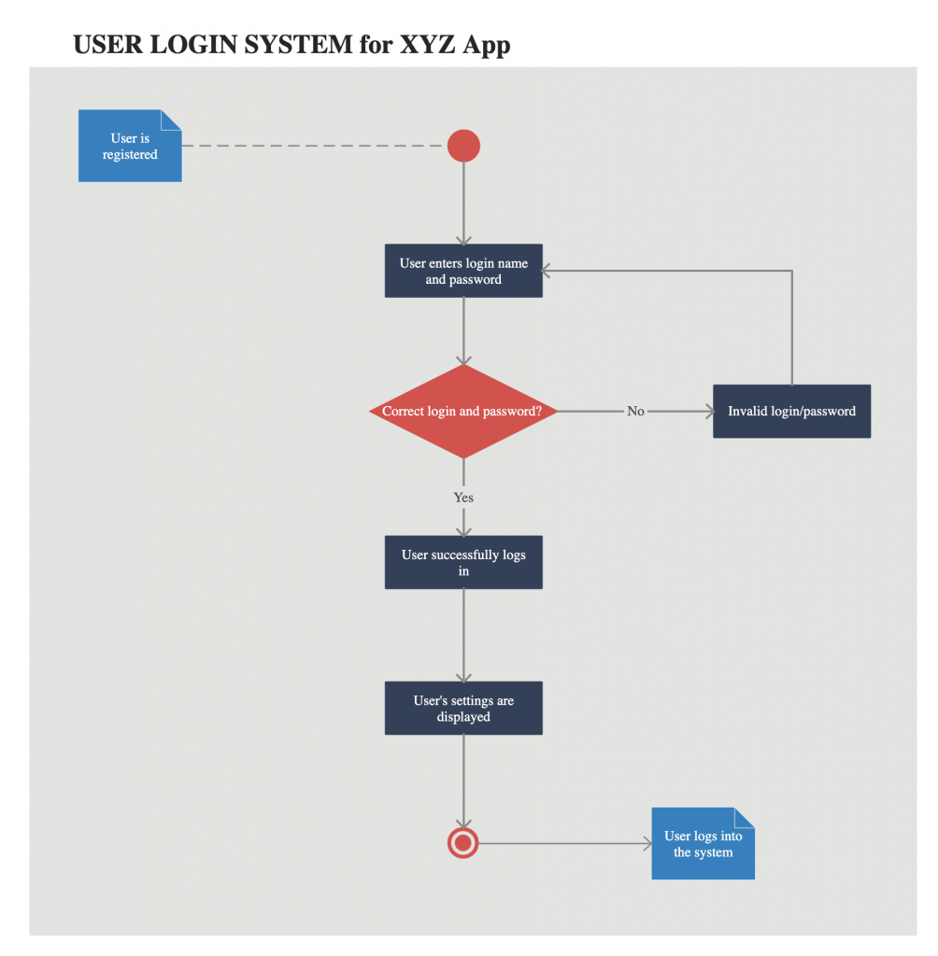
State Machine Diagram
State machine diagrams are similar to activity diagrams, although notations and usage change a bit. They are sometimes known as state diagrams or state chart diagrams as well. These are very useful to describe the behavior of objects that act differently according to the state they are in at the moment. The State machine diagram below shows the basic states and actions.
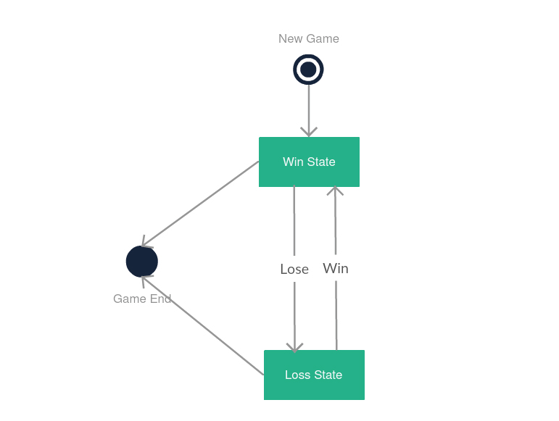

Sequence Diagram
Sequence diagrams in UML show how objects interact with each other and the order those interactions occur. It’s important to note that they show the interactions for a particular scenario. The processes are represented vertically and interactions are shown as arrows. This article explains the purpose and the basics of Sequence diagrams. Also, check out this complete Sequence Diagram Tutorial to learn more about sequence diagrams.

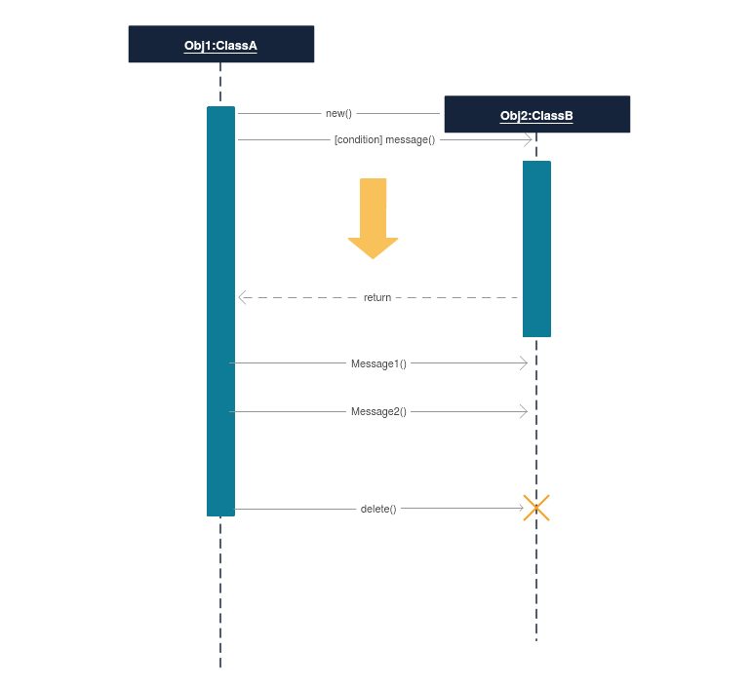

Communication Diagram
In UML 1 they were called collaboration diagrams. Communication diagrams are similar to sequence diagrams, but the focus is on messages passed between objects. The same information can be represented using a sequence diagram and different objects. Click here to understand the differences using an example.
